**University Event Monitoring And Tracker System**

**(Software Design Specification)**

**SOFTWARE DESIGN SPECIFICATION**

The decomposition of the project is as follows the following modules,

**MODULE 1: Event Management Module**

* **New Event Creation**: Creation of new event and Assigning Co-ord to it.
* **Finance Management**: Displaying all the Event Details and photo to the user and Announcement of Winners.
* **Content Management**: Display all the Financial info to the Admin and Co-ord.

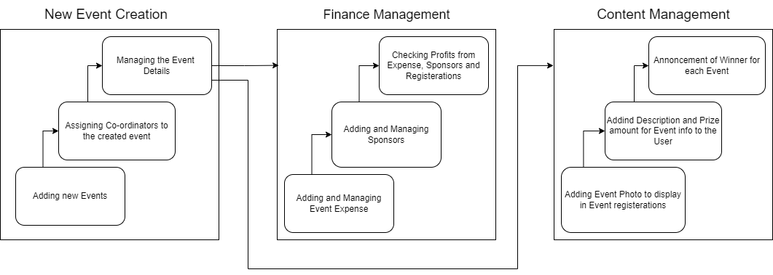

**Fig 2.1:** Event Management ModuleDiagram

**OUTPUT**

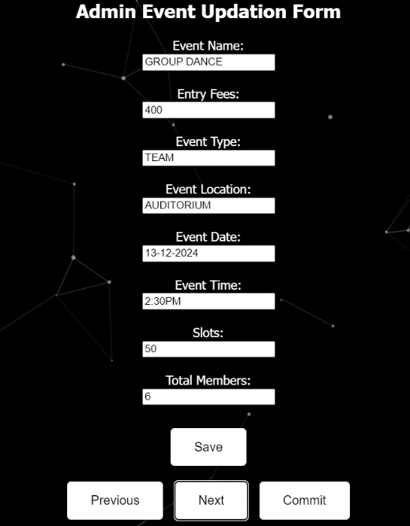

**Fig 2.2:** Manage Events

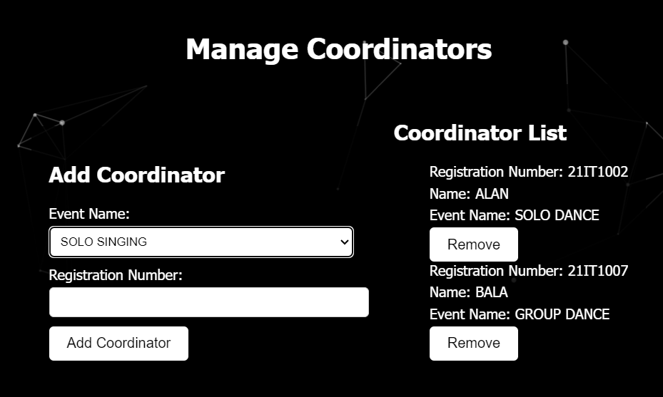

**Fig 2.3:** Manage Co-ord

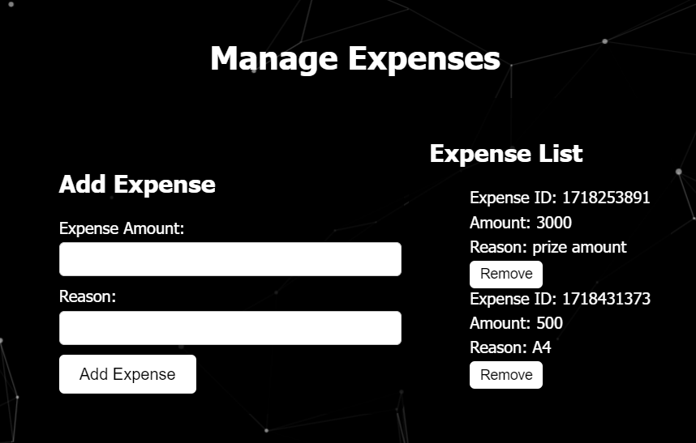

**Fig 2.4:** Manage Expense

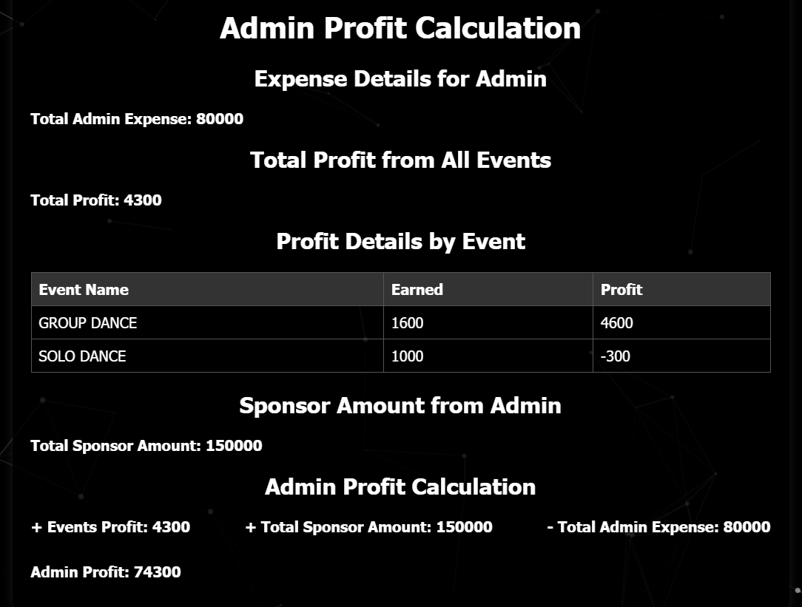

**Fig 2.5:** Admin profits

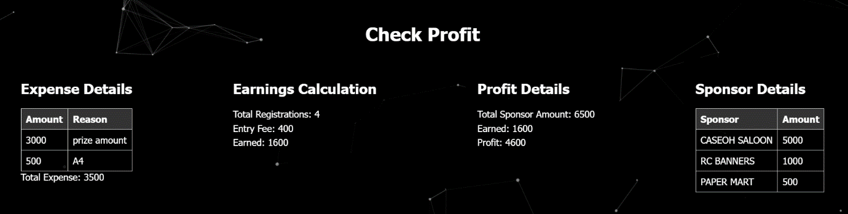

**Fig 2.6:** Co-ord Profits

**MODULE 2: End user registration with selection acknowledgement Module**

* **User Account Management**: Create new user account and Manage the user details and Automatically Display and insert the data of the User that has to entered in the Event Registration form.
* **Event Registration**: Display the desired Event Searched and Complete Payment to register a event.
* **Registered Event Management**: PDF generation of the registered event and to Display all the Events Registered with Event info.

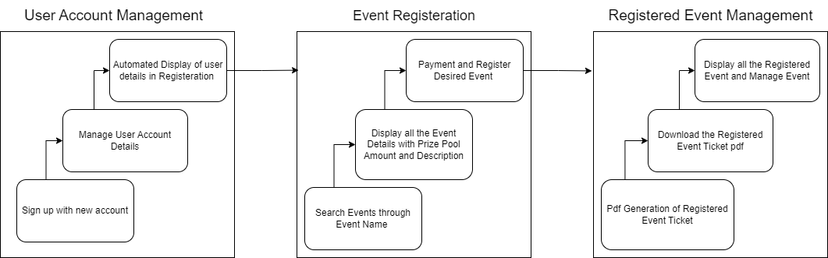

**Fig 2.7:** End user registration with selection acknowledgement Activity Diagram

**OUTPUT :**

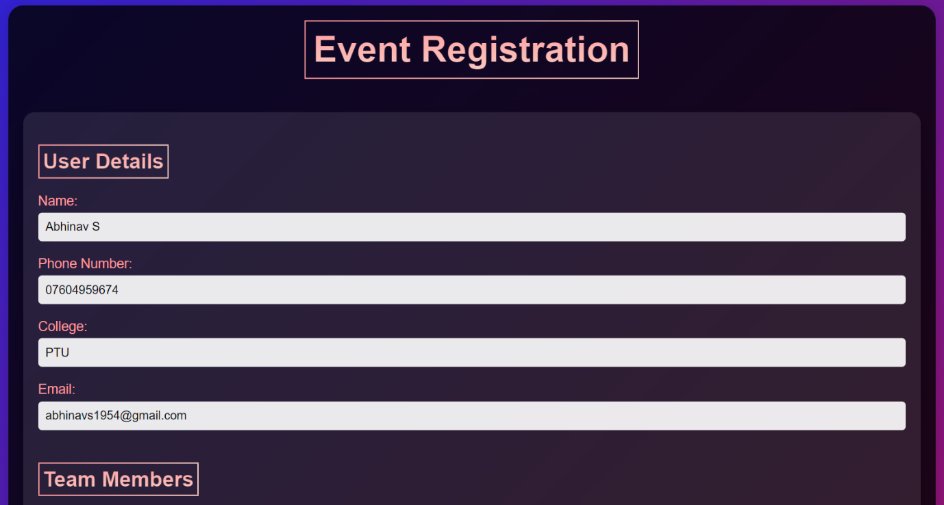

**Fig 2.8:** Automated User Data displayed in Registration form

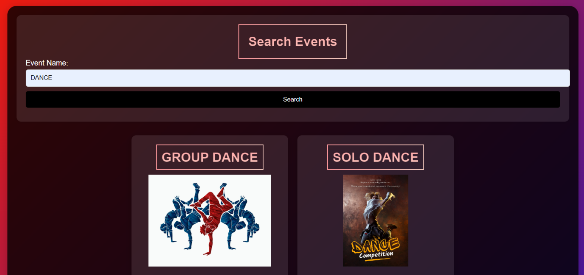

**Fig 2.9:** Event Search

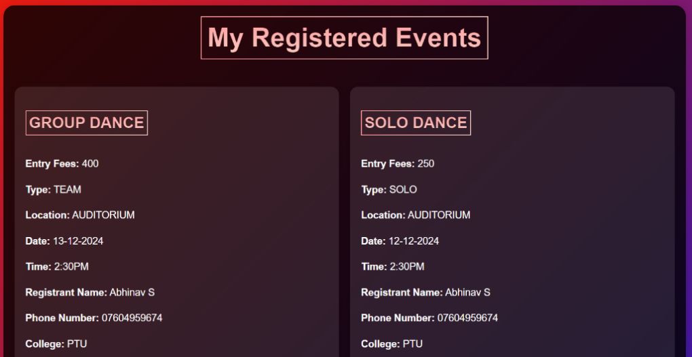

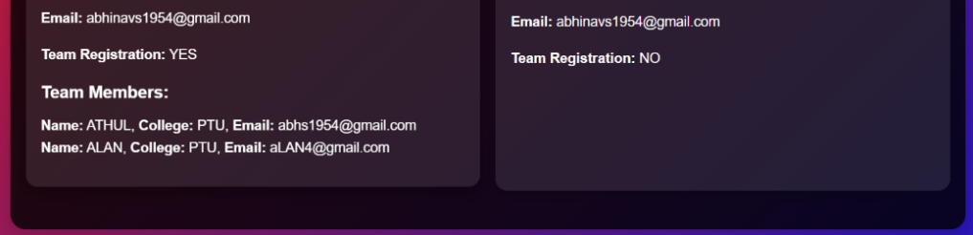

**Fig 2.10:** Displaying Registered Event in My Registration page

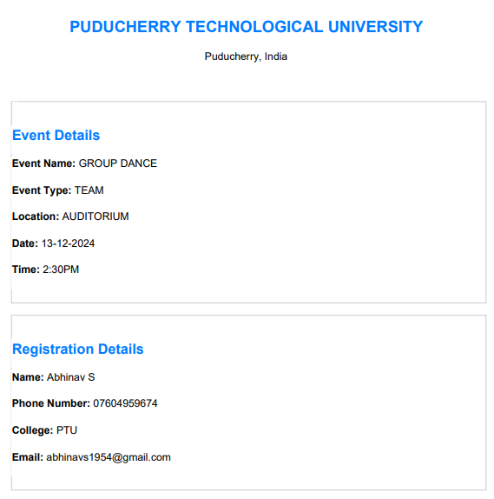

**Fig 2.11 :** Generated Registered Event’s PDF

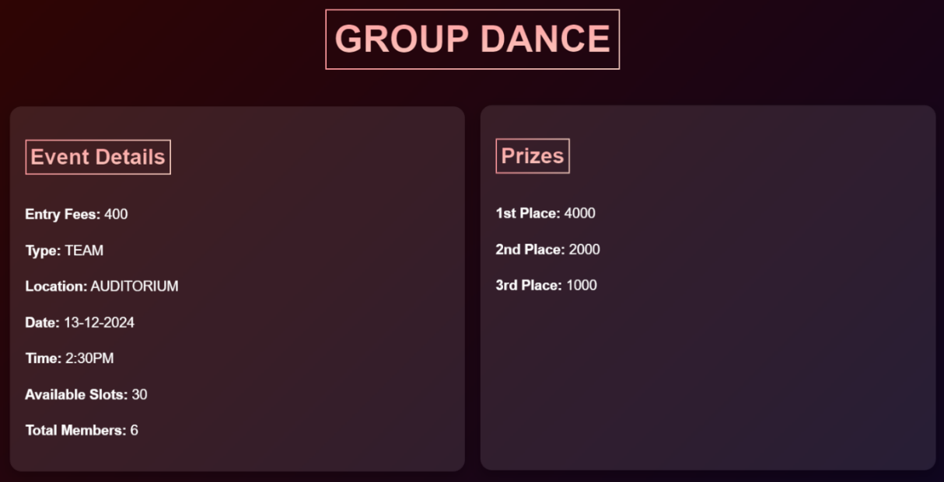

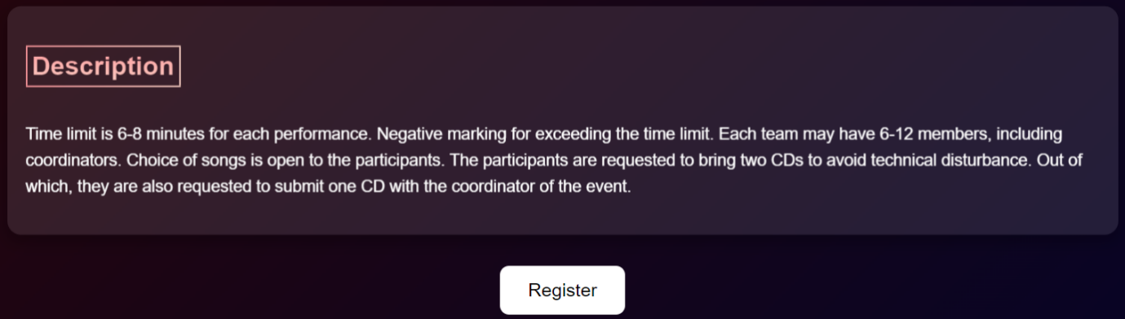

**Fig 2.12 :** Registering Event Content

**MODULE 3: Role based admin monitoring system Module**

* **Admin**: Designate one main admin with full access and control over the entire system.
* **Coordinator**:Coordinators can view and manage details specific to their assigned event only.
* **Voluntee**r: Volunteers access a simplified view focused on their assigned tasks and responsibilities.

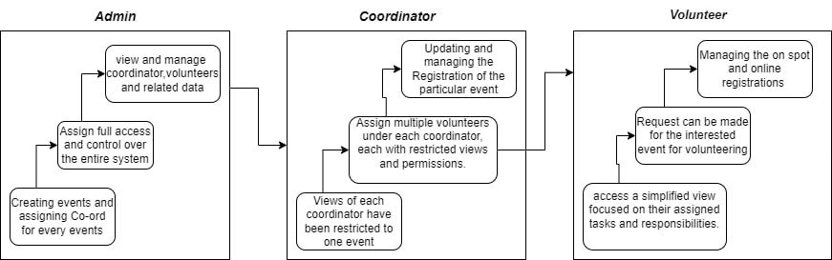

**Fig 2.13:** Role based Admin Monitoring system Activity diagram

**OUTPUT:**

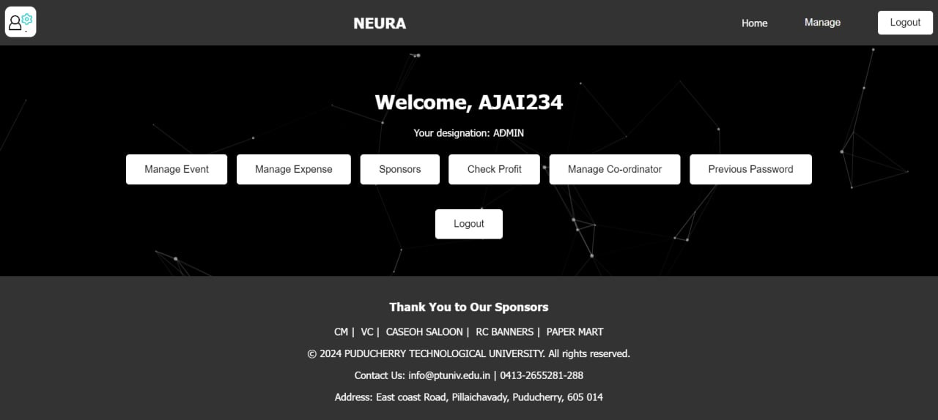

**Fig 2.14: Admin view**

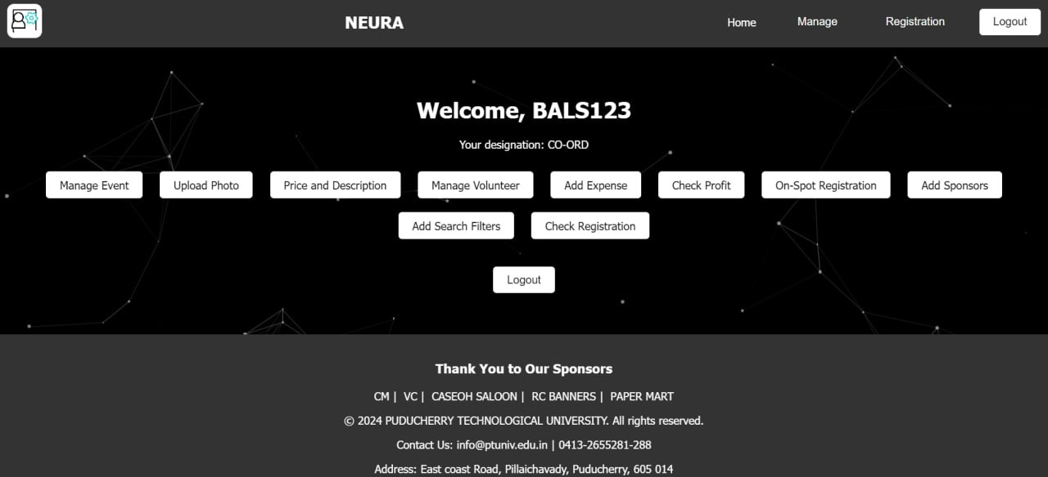

**Fig 2.15: Coordinator view**



**Fig 2.16: Volunteer view**